A Practical activity Report submitted

for Engineering Design Project-II (UTA-024)

by

**Vanshikaa 102103580**

**Submitted to**

**Dr. Jaswinder Kaur**



**DEPARTMENT OF ELECTRONICS AND COMMUNICATION ENGINEERING**

**THAPAR INSTITUTE OF ENGINEERING AND TECHNOLOGY, (A DEEMED TO BE UNIVERSITY), PATIALA, PUNJAB**

**INDIA**

**Jan-May 2023**

**Experiment: 2**

**Objective:**

1. To draw a schematic diagram of IR sensor module circuit (required to move Buggy module on a predefined the path) using CAD tool (Eagle).
2. To design a printed circuit board layout of IR sensor module circuit using CAD tool (Eagle).

**Software Used:** Eagle Software

**Component Used:**

|  |  |  |  |
| --- | --- | --- | --- |
| **Sr. No** | **Name of Components** | **Value** | **Specifications** |
| 1. | Resistor | 330 Ω , 10kΩ | Carbon Resistor with 5% Tolerance |
| 2. | Potentiometer | 10k | Variable Resistor |
| 3. | SFH482 |  | Infrared Emitters |
| 4. | BPX65 |  | Photodiode |
| 5. | LMV358MM |  | Dual Operational Amplifier |
| 6. | MTA02-100 |  | Connector |
| 7. | LED 3MM |  | Diode |

**Theory :**

1. **Resistor**-In electronics, a resistor is a passive two-terminal component that resists the flow of electrical current. It is used to regulate the amount of current in a circuit, reduce the voltage level, divide voltages, and provide a specific resistance value for proper circuit operation. The resistance of a resistor is specified in ohms and is indicated by its color code or numerical value printed on the component. Resistors can be fixed or variable, with fixed resistors having a fixed resistance value and variable resistors allowing for adjustable resistance.

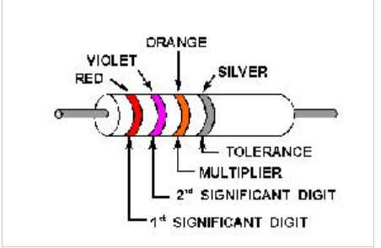**Resistors colour Coding** uses colored bands (shown in figure) to quickly identify a resistors resistive value and its percentage of tolerance with the physical size of the resistor indicating its wattage rating.

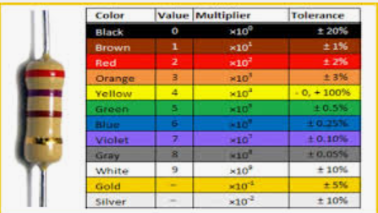

**Fig. 2.1** Various types of resistors [1]

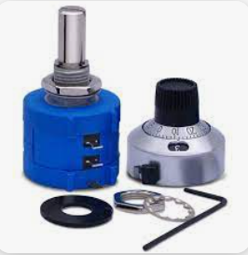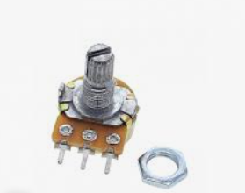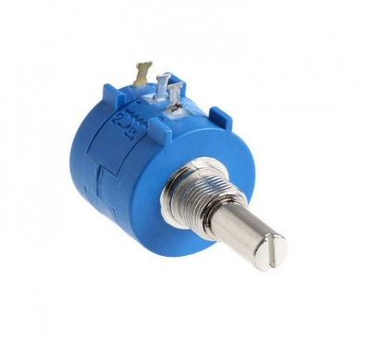 2. **Potentiometer**: A **potentiometer** is an electrical component that acts as a variable resistor. It is used to adjust the voltage or current in a circuit by manually changing the resistance value through a rotating shaft or sliding contact. This allows the user to control the flow of electrical energy in a circuit, and can be used for a variety of applications, such as volume control in audio equipment, calibration of electronic instruments, and regulation of power supplies.

**Fig. 2.2** Representation of Potentiometer with variable resistor [2]

1. **SHF482**: The term "infrared emitters" from SHF482 is theoretically applicable to all devices that emit infrared light. Some of them can be used as broadband infrared light sources for applications in spectroscopy, for instance, when the very low brightness is acceptable. Some of them are special types of incandescent lamps, sometimes in a very compact shape.

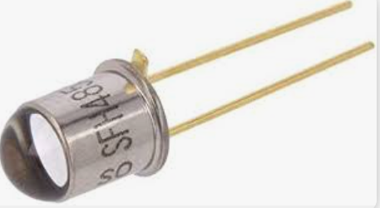

**Fig. 2.3** Representation of SHF482 (Infrared Emitter) [3]

4. **BPX65**: A photodiode, such as the BPX65, aids in the conversion of light into electrical current. It is made of a semi-conductor material, has a p-n junction, and is intended to operate under reverse bias. When photons are absorbed, current is generated in the photodiode. A tiny amount of current is also generated when there is no light.

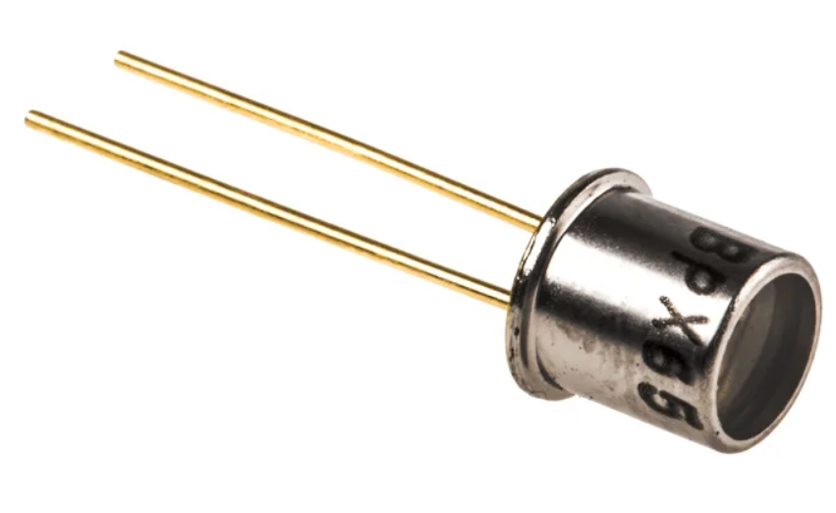

**Fig. 2.4** Voltage regulator BPX65 [4]

5. **LMV358MM**: The dual operational amplifier LMV358MM has two separate, high-gain, frequency-corrected operational amplifiers. It is made to work with voltages ranging from 3 to 32V from a single power source.

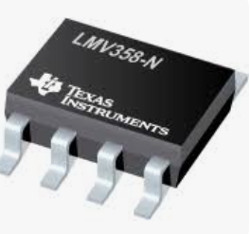

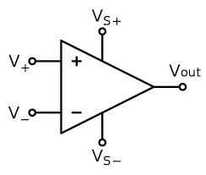

**Fig. 2.5 LMV358MM (Dual OP Amplifier) [5]**

6.**MTA02-100**: A wire-to-board and wire-to-wire system called the Connector System uses insulation displacement contact (IDC) technology.

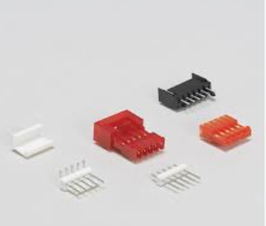

**Fig. 2.6** MTA02-100 [6]

7. **LED 3MM**: P-n junctions in light-emitting diodes are highly doped. When forward biassed, an LED will emit a coloured light at a certain spectral wavelength depending on the semiconductor material employed and the degree of doping. 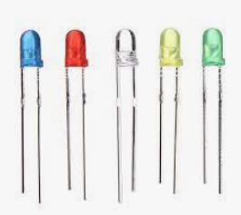

**Fig. 2.7** LED 3MM

**Schematic diagram:**

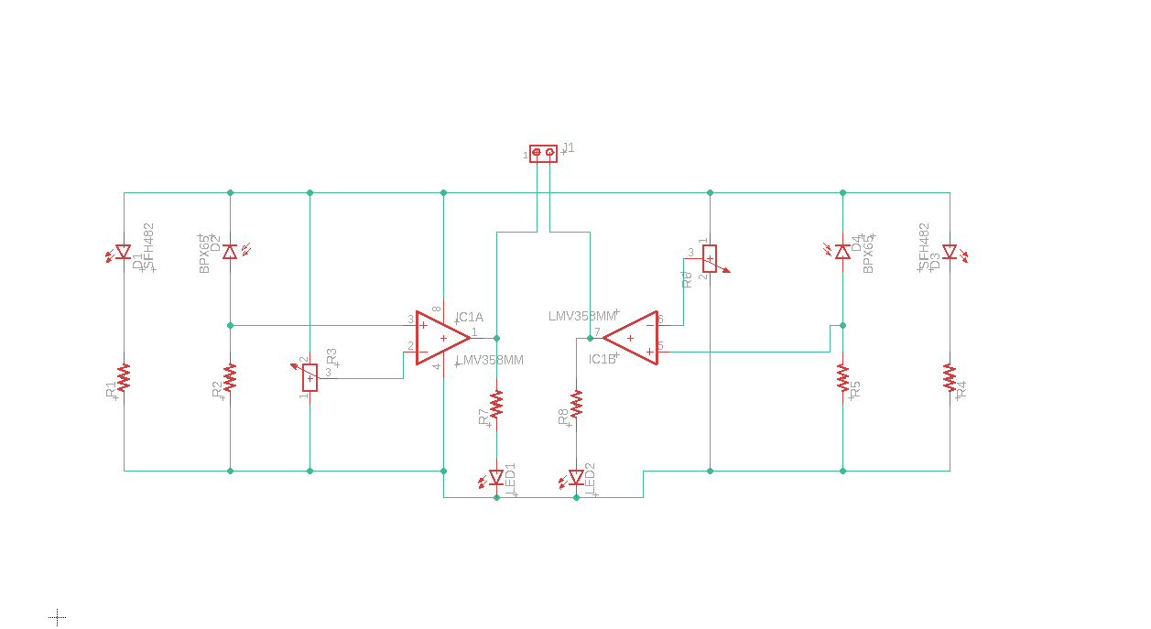

**Fig. 2.8** Schematic diagram of IR Sensor Module

**Printed Circuit Board layout:**

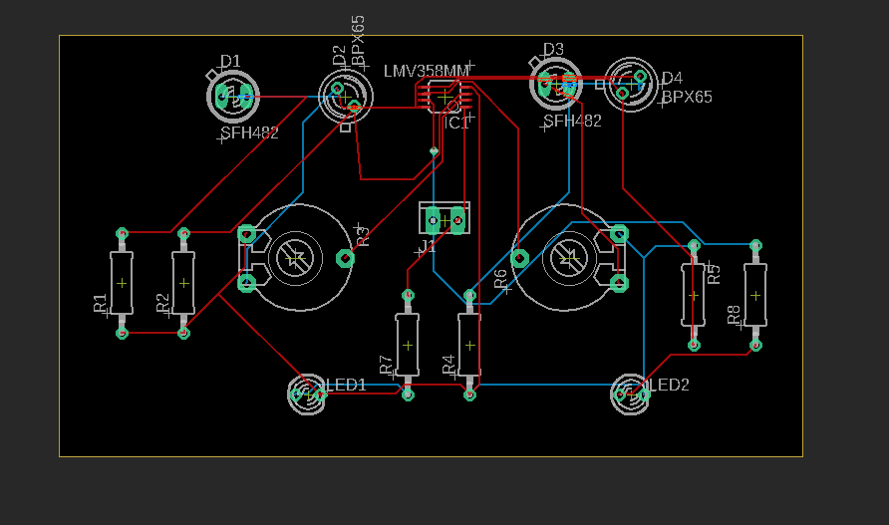

**Fig 2.9 PCB Layout for IR Sensor Module**

**Discussion:**

In this experiment, we learned how to construct an IR Sensor Module for our Buggy Project, which aids in determining the path for the Buggy. Here, the IR Emitter Diode emits infrared radiations to the ground and, in accordance with the principle, the White Area of the Ground Reflects Back the Transmitted Light to the Photodiode which Gives the Voltage Output to the Dual OP Amp, Leading to the Blinking of LED, Displaying the IR Sensor emits radiation into the dark region, but the darkness almost completely absorbs.

The BPX65 Diode and LED do not glow because the IR Sensor transmits radiation to the black region, which black nearly completely absorbs. This results in practically no potential drop in the OP Amp and no production of charges within the BPX65 Diode.

This module's primary function is to steer the buggy via an IR sensor so that it can travel the whole track while maintaining the black line between the sensors.

**Refrences :**

1. **https://www.techtarget.com/whatis/definition/resistor**
2. **https://www.electronics-tutorials.ws/opamp/opamp_1.html**
3. **https://en.wikipedia.org/Potentimeter**
4. **https://en.wikipedia.org/wiki/Light-emitting_diode**
5. **https://components101.com/IR_sensors**
6. [**https://en.wikipedia.org/wiki/Power_supply**](https://en.wikipedia.org/wiki/Power_supply)

**Signature of Faculty member**